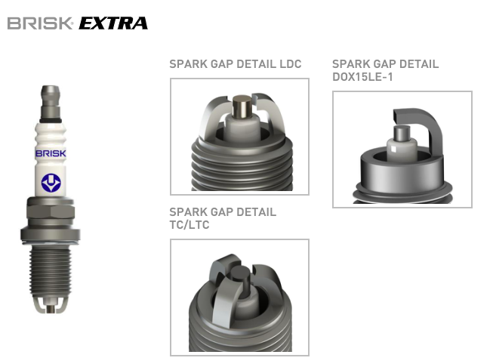
WIDE RANGE SPARK PLUGS WITH EXTENDED REPLACEMENT INTERVAL

Wide range spark plugs with extended replacement interval.
Replacement interval: see table below.

Two or three ground electrodes, or special design spark gap and electrodes (DOX15LE-1), which makes it possible to extend the replacement interval up to 60,000 km. Centre electrode with copper core and higher thermal conductivity ensures perfect function in all engine operating conditions. Some types allow alternative discharge from the combustion deposits on the insulator tip.

EXPLANATIONS TO THE TABLE:
* custom production
P sealing washer
K sealing cone

code |  | custom | electrode gap |  | gasket/seal | Interval | key dimensions |  |  | thread length |  | Thread
 | DOX15LE-1 | 1501 | 1,0 | P |  | max. 60.000 km |  | 16 mm | 22 mm | M 14x1,25 | 20-30 Nm
 | DR15LDC | 1372 | 0,8 | P |  | max. 45.000 km |  | 16 mm | 19 mm | M 14x1,25 | 20-30 Nm
 | DR15LDC-1 | 1373 | 1,0 | P |  | max. 45.000 km |  | 16 mm | 19 mm | M 14x1,25 | 20-30 Nm
 | DR17LDC | 1374 | 0,8 | P |  | max. 45.000 km |  | 16 mm | 19 mm | M 14x1,25 | 20-30 Nm
 | DR17LDC-1 | 1375 | 1,0 | P |  | max. 45.000 km |  | 16 mm | 19 mm | M 14x1,25 | 20-30 Nm
 | DR14TC | 1384 | 0,8 | P |  | max. 60.000 km |  | 16 mm | 19 mm | M 14x1,25 | 20-30 Nm
 | DR14TC-1 | 1385 | 1,0 | P |  | max. 60.000 km |  | 16 mm | 19 mm | M 14x1,25 | 20-30 Nm
 | DR15TC | 1329 | 0,8 | P |  | max. 60.000 km |  | 16 mm | 19 mm | M 14x1,25 | 20-30 Nm
 | DR15TC-1 | 1328 | 1,0 | P |  | max. 60.000 km |  | 16 mm | 19 mm | M 14x1,25 | 20-30 Nm
 | DR17TC | 1345 | 0,8 | P |  | max. 60.000 km |  | 16 mm | 19 mm | M 14x1,25 | 20-30 Nm
 | DR17TC-1 | 1346 | 1,0 | P |  | max. 60.000 km |  | 16 mm | 19 mm | M 14x1,25 | 20-30 Nm
 | DX15LTC-1 | 1349 | 1,0 | P |  | max. 60.000 km |  | 16 mm | 19 mm | M 14x1,25 | 20-30 Nm
 | LR14TC | 1416 | 0,8 | P |  | max. 60.000 km |  | 21 mm | 19 mm | M 14x1,25 | 20-30 Nm
 | LR14TC-1 | 1457 | 1,0 | P |  | max. 60.000 km |  | 21 mm | 19 mm | M 14x1,25 | 20-30 Nm
 | LR15TC | 1323 | 0,8 | P |  | max. 60.000 km |  | 21 mm | 19 mm | M 14x1,25 | 20-30 Nm
 | LR15TC-1 | 1331 | 1,0 | P |  | max. 60.000 km |  | 21 mm | 19 mm | M 14x1,25 | 20-30 Nm
 | LR17TC | 1347 | 0,8 | P |  | max. 60.000 km |  | 21 mm | 19 mm | M 14x1,25 | 20-30 Nm
 | LR17TC-1 | 1348 | 1,0 | P |  | max. 60.000 km |  | 21 mm | 19 mm | M 14x1,25 | 20-30 Nm
 | LX15LTC-1 | 1350 | 1,0 | P |  | max. 60.000 km |  | 21 mm | 19 mm | M 14x1,25

